The new parameters of SECTION

Problem
PrintBos engine executes scripts:
- for InputFields while reading data from JOB
- for OutputFields while calculating section objects
Thus, scripts have no way to get real coordinates of OutputFields.

Solution
It is necessary to provide the ability to assign\execute scripts for SECTION(s):
- run script(s) after each iteration of DATA subsection
- run script(s) after each iteration of the entire section

Implementation
- Designer
Is need to add the ability to assign a script and its run type to a SECTION object (Templates & Subtemplates).
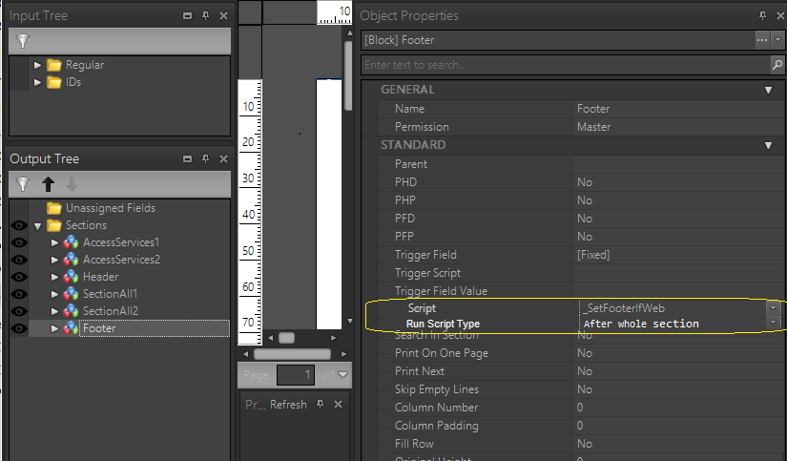
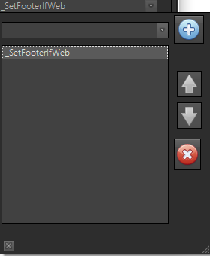
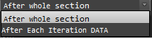

“Script” – item for the "script selection" dialog popup
“Run Script Type” - combobox
- After whole section - (value 0) default
- After each iteration DATA - (value 1)

In during save template/subtemplate these parameters need save as:

[Block 5]
…….
Name=Footer
………………..
Script=_SetFooterIfWeb
RunScript=0
………………….

- Engine
Implementation of section script processing in the engine.

